**ShopNest Store**

ShopNest stands as the leading department store in the e-commerce marketplaces in Portugal. Serving as a seamless link, it connects small businesses from various regions in Portugal to channels, streamlining the process with a single point of contact.

Through the ShopNest Store, these merchants can showcase and sell their products, with the added convenience of direct shipment to customers facilitated by ShopNest logistics partners. The provided data represents authentic commercial information that has undergone the process of anonymization.

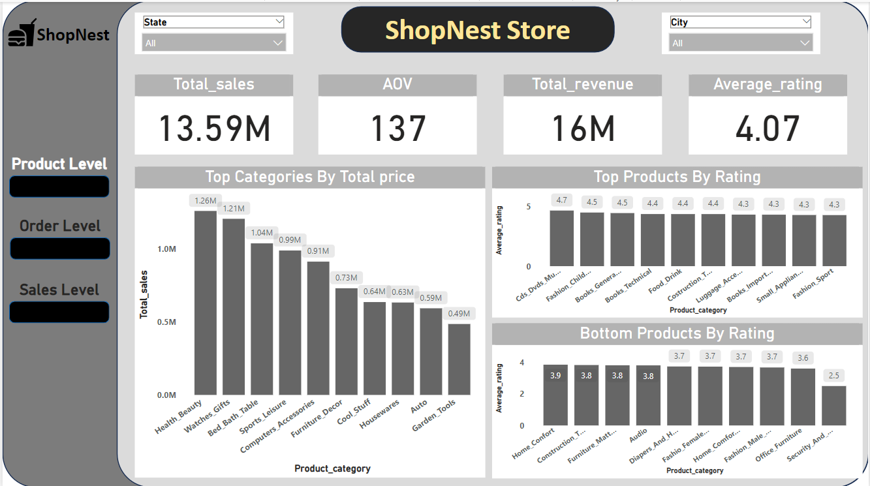

## **Question: Top Categories by Total Price**

## **Visualization:**

# 

# **Explanation:**

* The chart lists the top product categories based on total sales prices, with "Health Beauty" leading at 1.26M, followed closely by "Watches Gifts" at 1.21M.
* These categories should be prioritized in inventory management and promotional strategies.

## **Question: Delayed Orders Analysis**

## **Visualization:**

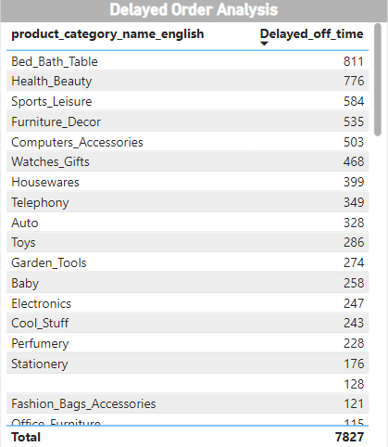

# **Explanation:**

* Bed & Bath Table has the highest delayed off time at 811, indicating significant challenges in this category.
* Health & Beauty follows closely with 776 delayed orders, also warranting attention.
* It may be low stock availability, Low/ High demand, Size of the product etc.

## **Question: Monthly Comparison of Delayed and On-Time Orders**

## **Visualization:**

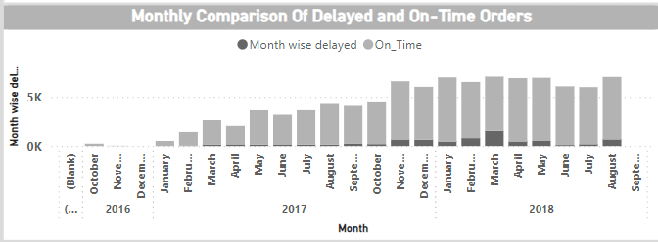

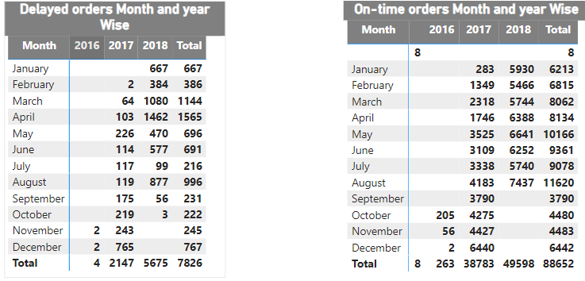

# **Explanation:**

* In 2018, April and March have the maximum number of Delayed orders which are around 40% of 2018 year.
* From, both the tables we can see that year-by-year numbers of both Delayed and on time orders both are increasing.
* Ensure that workflow during peak periods (e.g., March and April) is efficient to maintain on-time performance.

## **Question: Payment Method Analysis**

## **Visualization:**

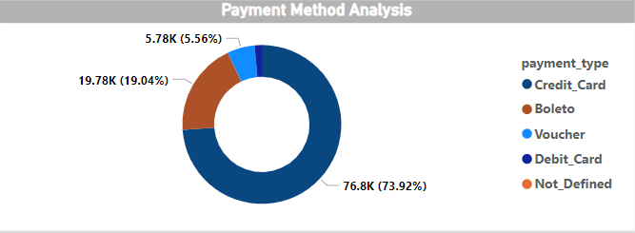

# **Explanation:**

* Approx, two-third of the payments are done by credit card (73.92%).
* And, 19% are done by Boleto and rest by other.
* More Offers and cashback can be given on other mediums to increase their sale also.

## **Question: Product Rating Analysis**

## **Visualization:**

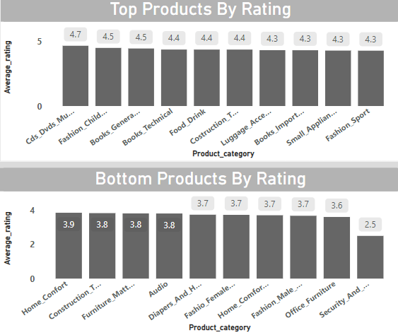

# **Explanation:**

* CDs and DVDs have the highest average of customers review score (rating) so, it means the product is good and customers are also satisfied from it.
* Security and Services have the lowest average rating this could be due to bad experience faced by customers towards this product.

## **Question: State-wise Sales Analysis**

## **Visualization:**

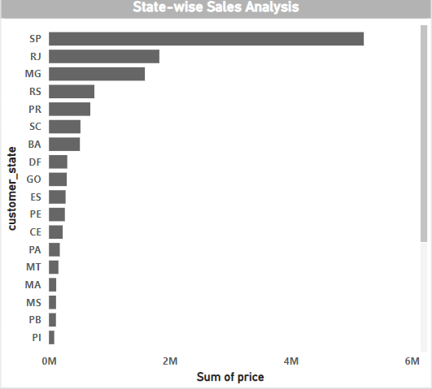

# **Explanation:**

* SP leads significantly in sales, with a total sum of sales close to 6 million.
* RJ and MG also show substantial sales, although lower than SP.
* This analysis can help in identifying key markets and potential areas for growth or increased focus.

## **Question: Seasonal (Quarterly) Sales Patterns**

## **Visualization:**

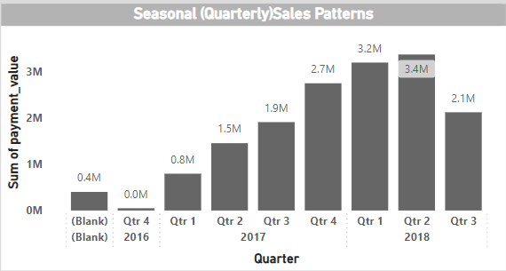

# **Explanation:**

* Sales in 2017 show consistent growth from Q1 (0.8M) to Q4 (2.7M).
* Q2 2018 experiences the highest sales peak at 3.4M.
* There is a noticeable seasonal trend with increasing sales toward the end of each year and the beginning of the next year

## **Question: Revenue Analysis**

## **Visualization:**

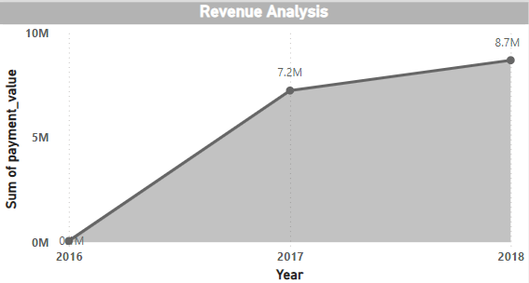

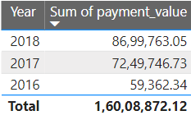

# **Explanation:**

* There has been substantial growth from 2016 to 2018. As, the graph is increasing its good for the companies.
* There is a huge jump in between 2016 and 2017 this indicates good product planning and strategy towards market and customers.